Take a router 2911 and PC0.

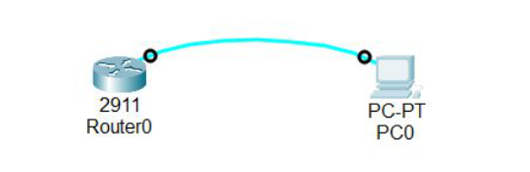

Then on router CLI

router>

router>en

router#conf t

router(config)#hostname r1

r1(config)exit

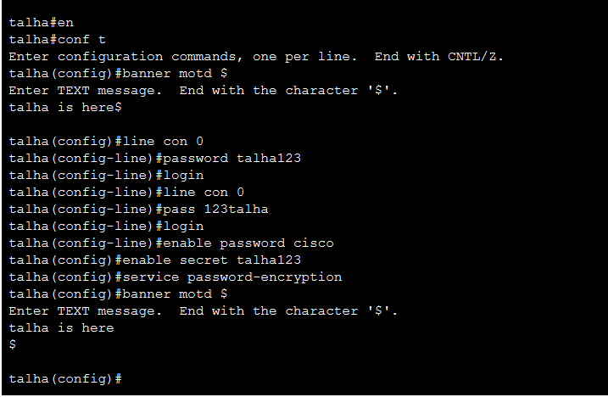

en

conf t

hostname talha2

banner motd $

this is talha$

line con 0

password talha123

login

enable password cisco

enable secret 123talha

service password-encryption